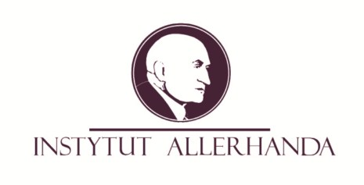

Allerhand Lecture Series: Prof. Dr. Christoph Teichmann

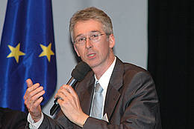

The Allerhand Institute has the pleasure of inviting you to another seminar entitled the Allerhand Lecture Series, where guest speaker will discuss a current affair that falls under the research interests of the Allerhand Institute law and economics. After the lecture, there will be a moderated discussion with the speaker.
It is our pleasure to welcome our guest speaker Prof. Dr. Christoph Teichmann, Professor of Civil Law, German and European corporate and commercial law at Julius Maximilian University of Würzburg with the lecture:
‘Corporate Mobility in the European Union - Recent Developments’.
Companies enjoy the freedom of establishment in the whole European Union. The question is what 'free establishment' means in the case of a company. Is it only the establishment of a place of business? Or is it also the transfer of the seat including a change of the applicable company law? The speaker will talk about the leading cases of the European Court of Justice and will elaborate a new approach challenging the common distinction between inbound- and outbound-mobility.

The Commentators will be: Arkadiusz Radwan, PhD and Krzysztof Oplustil, post-PhD.

We kindly invite you to join us on 26. April 2012 at 18:00 at the Allerhand Institute Plac Sikorskiego 2/7, Krakow.
Due to the limited space please confirm your participation by sending an e-mail to als@allerhand.pl

Participation in Allerhand Lecture Series is free, however should you be unable to attend an event for which you are registered, you are requested to give 24 hour notice, so that we can notify those on the waiting list.

